How to Check Company Profitability for a Specific Period in Odoo 19
Rohan Raj | Feb 09, 2026

To review business performance, it is important to understand whether a company is profitable during a specific period. Management teams usually require a clear picture of the amount of revenue earned, the amount of expenses incurred, as well as whether the company has made a profit or loss at the end of the period. Odoo provides this information through Profit and Loss reporting within the accounting app, allowing users to review profitability for any selected time frame without manual calculations.
Accounting App => Reporting => Profit and Loss

Understanding the Profit and Loss Report
When the Profit and Loss report is opened, the screen displays a summary of the company’s financial performance for a particular period.

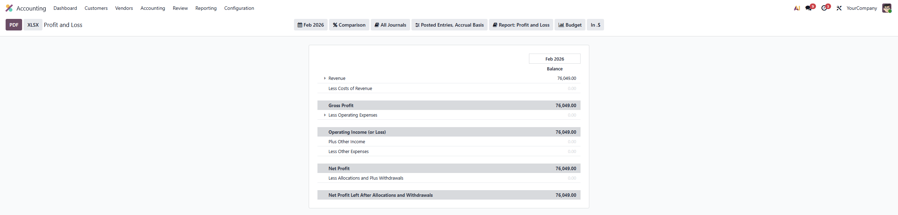
Profit and Loss Report for February

In the Profit and Loss report table, Odoo shows the company’s income and expenses for the selected period, making it easy to see whether the company made a profit or loss. The report displays revenue earned during the period, followed by the direct costs required to generate that revenue to calculate gross profit. Operating expenses such as salaries and rent are subtracted from gross profit to determine operating income (or loss). Finally, other income, expenses and adjustments are applied to show the net profit at the end of the report.

Selecting a Specific Period
To view the Profit and Loss report for a particular period of time, click the button at the top of the report that displays the current period. From here, select the required month, quarter, year or custom date range.

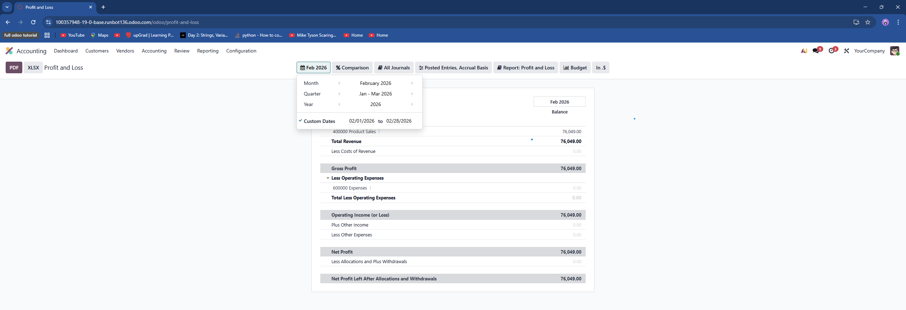

Once a period is selected, the Profit and Loss report refreshes to show data for that timeframe. The image below shows the Profit and Loss report for the quarter January to March 2026, Here the company earned a net profit of 49,695.30 indicating that the company was profitable during the period.
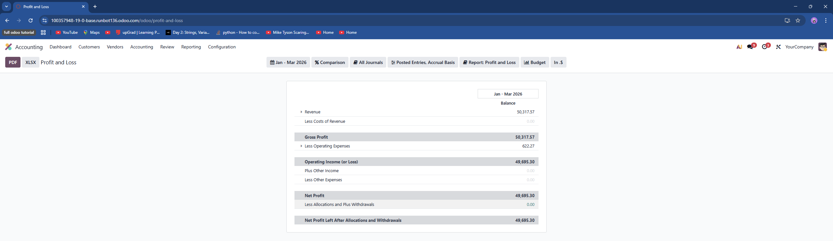

In the report, the gross profit represents the revenue remaining after deducting the cost of revenue. Below this, operating income (or loss) shows the amount left after operating expenses are deducted from the gross profit. Finally, the net profit shows the company’s profit after considering all operating activities along with other incomes and expenses during the selected period. Also, the net profit after any allocations and withdrawals is shown at the bottom of the report.
Using the Profit and Loss report in Odoo 19, users can easily check whether a company is profitable for any selected period by reviewing the net profit shown in the report.

